**SQL Exercise - Index.sql**

**Exercise 1: Creating a Non-Clustered Index**

**Step 1: Query to fetch product details before index creation**

SELECT * FROM Products WHERE ProductName = 'Laptop';

**Step 2: Create a non-clustered index on ProductName**  
CREATE INDEX idx_productname ON Products(ProductName);  
**Step 3: Query to fetch product details after index creation**

SELECT * FROM Products WHERE ProductName = 'Laptop';

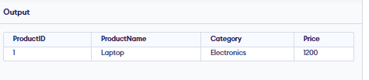

**Exercise 2: Creating a Clustered Index**

**Step 1: Query to fetch orders before index creation**

SELECT * FROM Orders WHERE OrderDate = '2023-01-15';

**Step 2: Create a clustered index on OrderDate**

CREATE CLUSTERED INDEX idx_orderdate_clustered ON Orders(OrderDate);

**Step 3: Query to fetch orders after index creation**

SELECT * FROM Orders WHERE OrderDate = '2023-01-15';

**Exercise 3: Creating a Composite Index**

**Step 1: Query to fetch orders before index creation**

SELECT * FROM Orders WHERE CustomerID = 1 AND OrderDate = '2023-01-15';

**Step 2: Create a composite index on CustomerID and OrderDate**

CREATE INDEX idx_customer_orderdate ON Orders(CustomerID, OrderDate);

**Step 3: Query to fetch orders after index creation**

SELECT * FROM Orders WHERE CustomerID = 1 AND OrderDate = '2023-01-15';

